Matthew Clayson 1887 – 1916
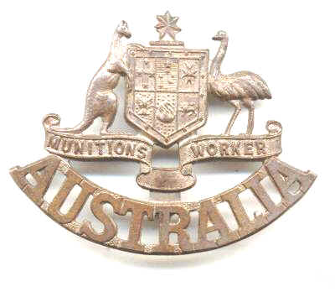
Why should we remember Matthew Clayson, a man from Sydney who died in his “own” bed without hearing a shot fired in anger? He may have never attended mass at St Werburgh’s, as he only lived in Chester for just over a week. He was not included on the 1922 plaque nor 1990 scroll.

The centennials of 1914-1918 are a fitting time to think back and reconsider some things that were taken for granted in days gone by. Who is a parishioner of St Werburgh’s (or Werbie as we are now called)? What was the ultimate sacrifice? Whom should we remember?

I believe that Matthew Clayson was truly a Werbie, who made the ultimate sacrifice and deserves to be remembered today. His is a sad story that spans the globe and includes both love and tragedy.

Matthew Clayson was born in 1887 to Matthew and Mary Ann Clayson. They had been married in 1884 in St Bridget’s Church, Bradford, Lancashire – not Yorkshire! His father was a “soap mixer” and his mother the daughter of a career soldier who had served in Canada, where Mary Ann Ward was born, the UK and India. After leaving the Army William Ward worked as a “tar distiller”, a sideline of the coal industry.

Young Matthew Clayson grew up in Bradford, where the family lived next door to Mary Ann’s parents. By 1901 the family had moved to Gorton Lane, Gorton, in South East Manchester, close to Matthew's paternal grandparents. As they lived only a few hundred yards from the Church and Friary of St Francis, known locally as Gorton Monastery, they were probably parishioners and attended mass in the Pugin masterpiece of High Victorian Gothic architecture. Matthew attended the Technical School, but by age 14 he was already working as a mechanic. On leaving school he started an apprenticeship with Sir W.G. Armstrong Whitworth & Co Ltd, the famous armaments manufacturer.

By 1911 Matthew had moved with his mother and two sisters to another house in Gorton, and his father, Matthew Senior, was living close by. The 1911 Census describes the senior Clayson as a “soap maker (pensioned) - totally blind”. He had a family boarding with him, so it is likely that he had some support from them. He died in 1911, soon after the census was taken.

Gorton Monastery

In May 1912 Matthew set out on a great adventure by emigrating to Australia with William Linney, a friend of the family. Both men are described in the RMS Ophir's passenger list as “fitters”. On arriving in Sydney, Matthew went to work on the NSW Government Railway in Cowra, a country town in rural New South Wales.

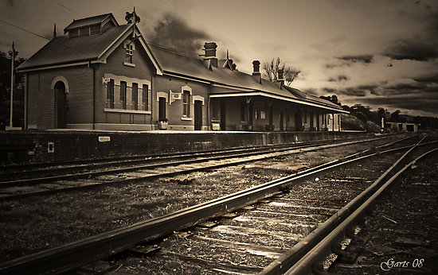
Cowra Railway Station

Just over a year later, Mary Ann Clayson, together with her daughters Edith and Annie, also migrated to Australia on RMS Suevic. They were joined on the ship by Jennie McCormick. The atmosphere on the voyage to Sydney must have been full of hope and anticipation for their new lives in Australia.

The Suevic docked in Sydney on Monday 15th December 1913. After a brief pause to catch up and finalise arrangements, on Wednesday 17th December 1913 the Claysons, William Linney and Jennie McCormick returned to the dock area of Sydney heading to St Augustine’s Church, Balmain North for a double wedding. The marriage register contains consecutive entries for the marriages of Matthew and Jennie followed by William and Annie. Jennie was also the daughter of a soldier, and had been born in Malta.

In 1916 Matthew left the NSW Railways and started a new job at the Naval Dockyard, Cockatoo Island, Sydney as a tool and gauge maker. In response to a shortage of workers with such skills in UK factories, the Australian and Imperial Governments agreed a programme to recruit chemists and other skilled men to bolster munitions production in the UK. The Australian Munitions Workers scheme started to seek volunteers in the middle of August 1916. The men had to be volunteers as Australia did not institute conscription during World War 1.

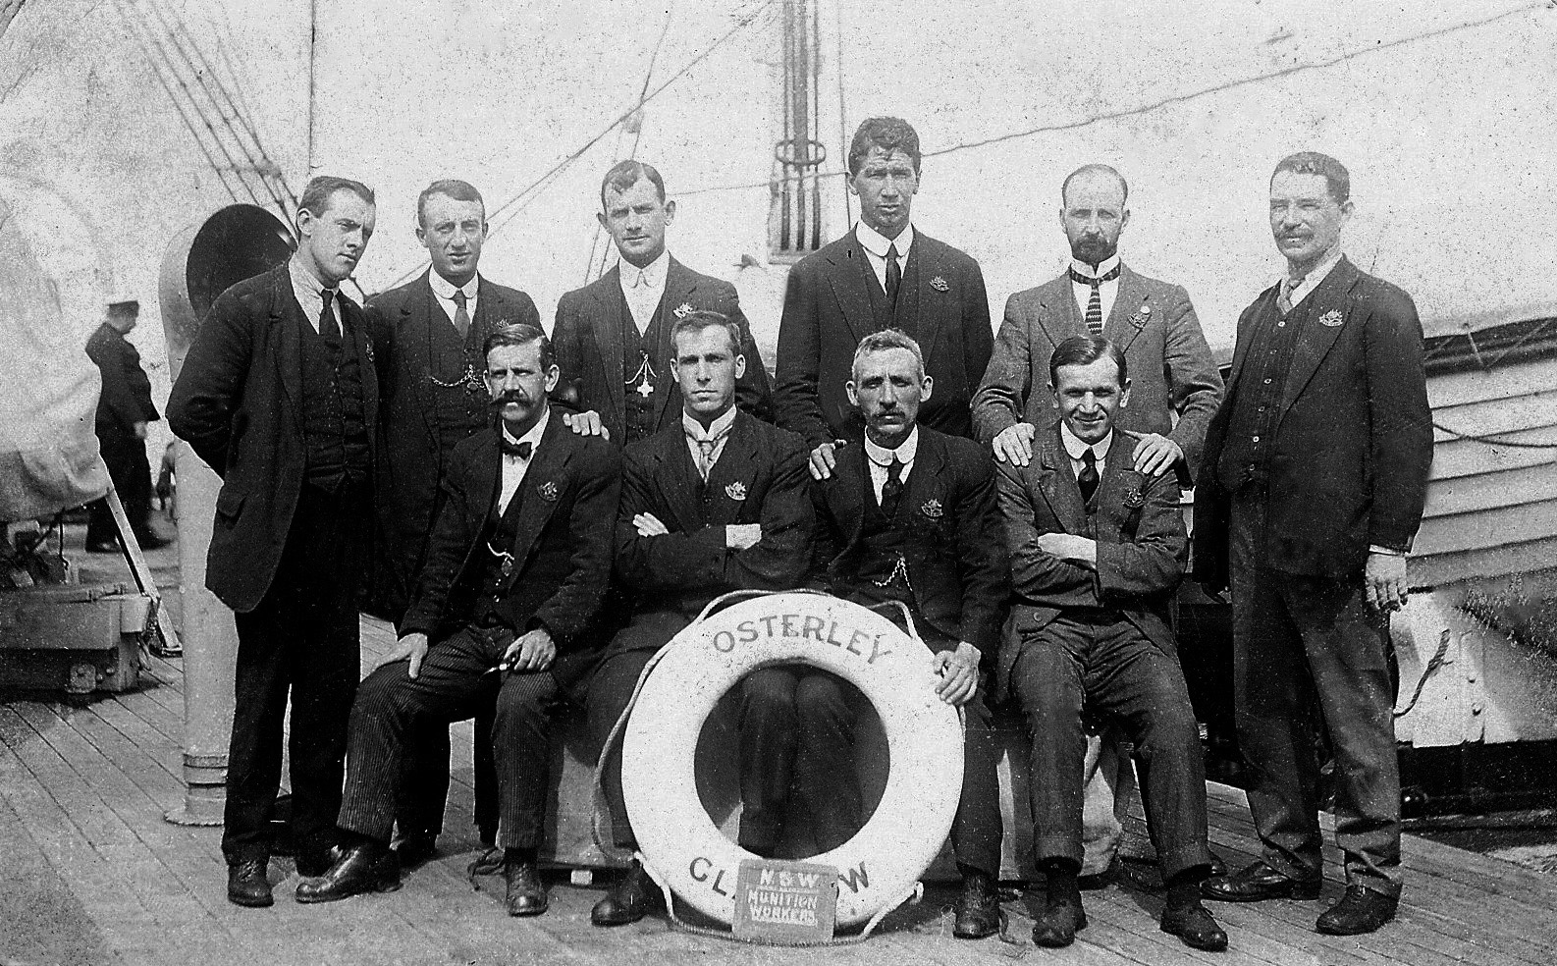
NSW Munitions Workers on SS Osterley October 1916. M Clayson Standing 2nd from Left.
A Chambers Seated 2nd from Left. Photo courtesy of Roslyn Spiteri

Matthew Clayson stepped forward and volunteered for the scheme on 30th August 1916. This must have been a hard decision for Matthew as he was, by this time, the father of two girls. He was accepted as volunteer number 22 and in just over three weeks he sailed from Sydney on SS Osterley with 77 other volunteers. The voyage via Cape Town to Tilbury lasted six weeks but was not uneventful. There were numerous complaints about the food, service and standards in 3rd Class accommodation. The threat posed by German submarines also added to the unease on the ship.

The Osterley arrived at Tilbury on 10th November 1916. After a few days in London, Matthew and fellow volunteer Alfred Chambers travelled up to Chester on the evening of 20th November. They arrived in Chester the next morning. Later that day they reported at H.M. Explosives Factory, Queensferry. They signed on and were examined by the Factory doctor.

On returning to Chester, Clayson and Chambers found lodgings together with Mrs Atkinson at 23 Cherry Road at £1.00 per week. It was reported that the lodgings were clean, very comfortable, and in a good neighbourhood.

Unfortunately during the stopover in Cape Town Matthew contracted a cold. After just 3 days work at Queensferry, the cold developed into lobar pneumonia. His condition deteriorated rapidly, and by Sunday evening he was too ill to be transferred to hospital. The help of Father Hayes was sought. He immediately sent for nursing sisters who remained with him day and night until he died at 1.00 a.m. on Friday 1st December 1916. The sisters were assisted by Jennie’s sister who came over from Manchester.

On Monday 4th December 1916 Matthew Clayson was buried in Chester Overleigh Cemetery in a shared grave with Madam Bertha Krebbs and Emily Jane Whitehouse. They had died in 1906 and 1914 respectively. Matthew’s grave is now marked with a Commonwealth War Graves Commission headstone. For what ever reason, a personal inscription was not added by his family. The original grave marker can still be seen in the cemetery.

The funeral arrangements were undertaken by Father Hayes, who was commended for being “in constant attention and took more than an ordinary interest in Clayson.” Father Hayes also wrote to Jennie twice and to her local parish priest in Sydney.

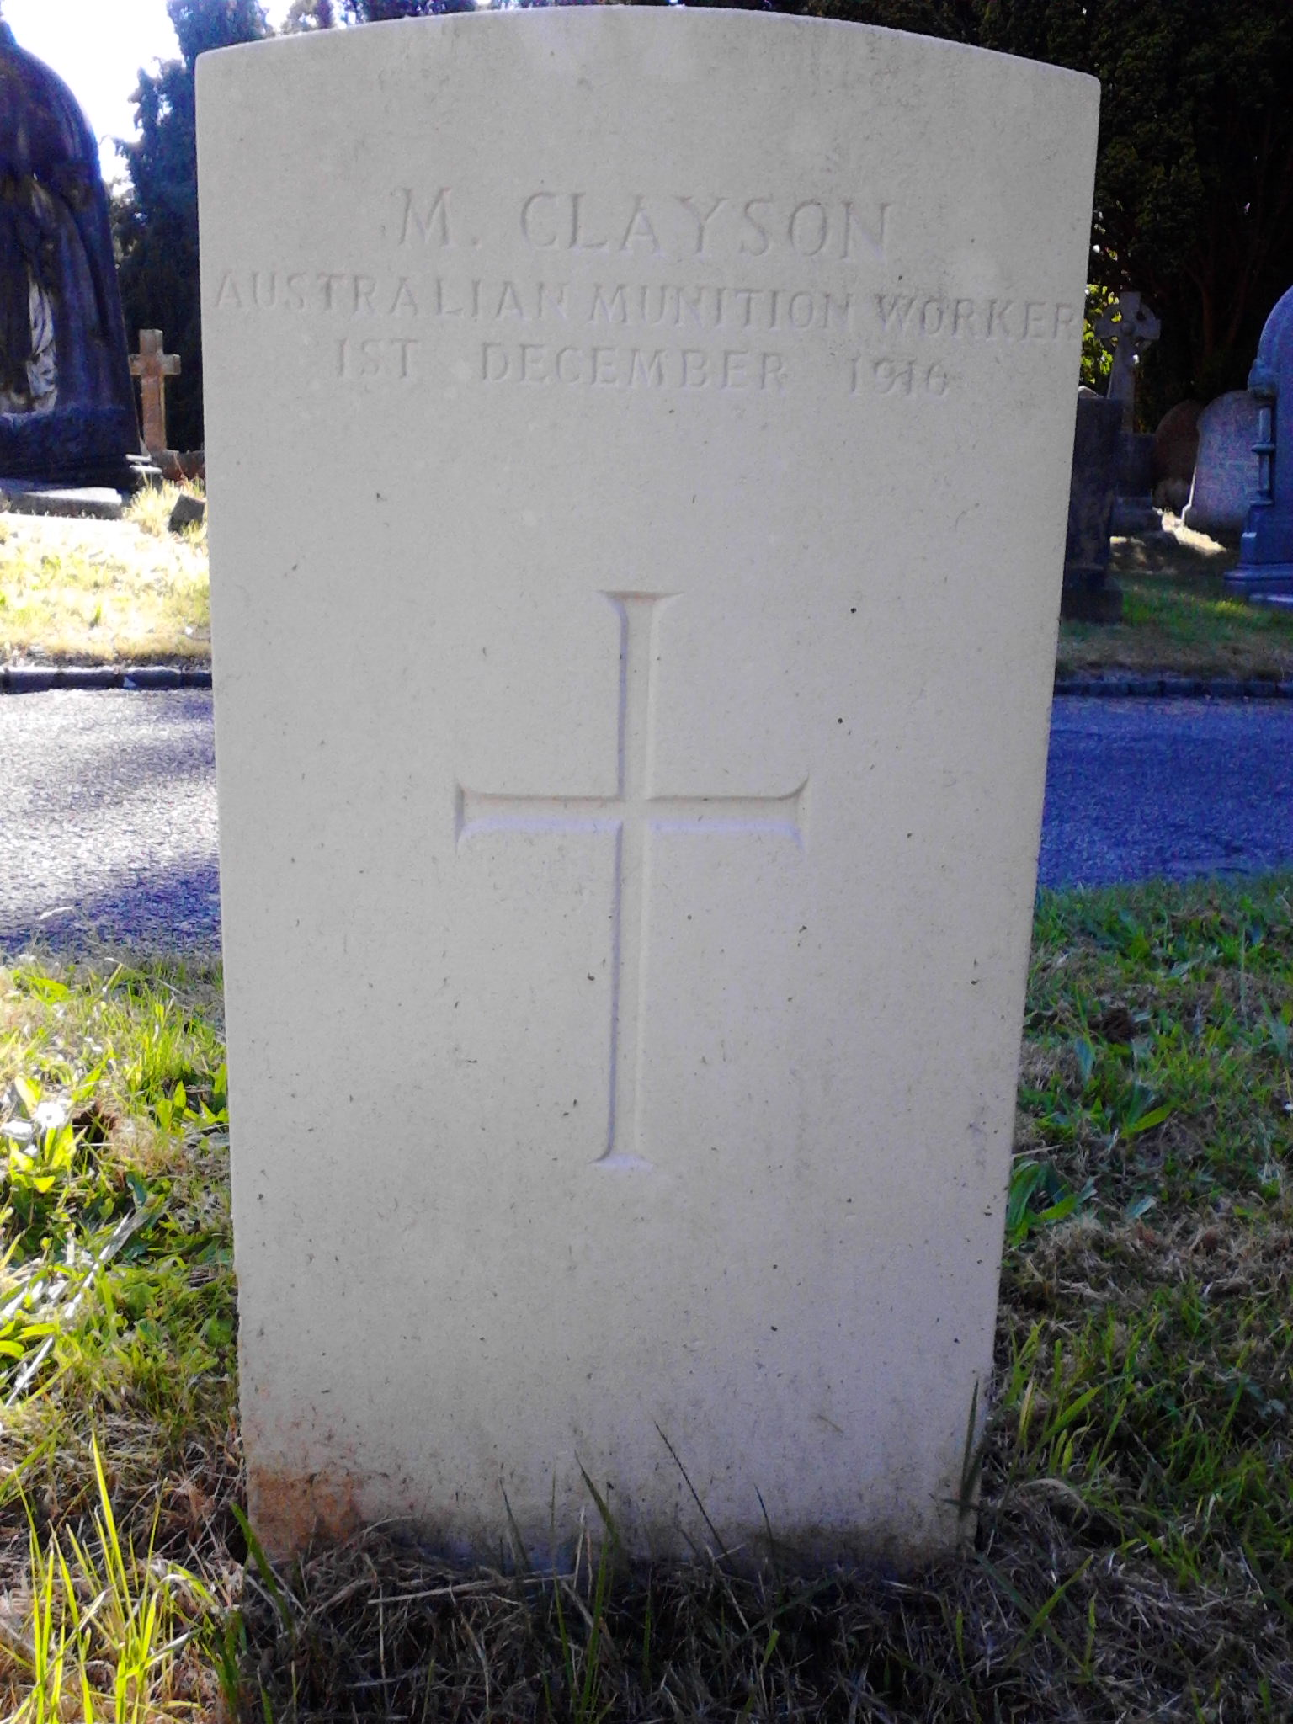
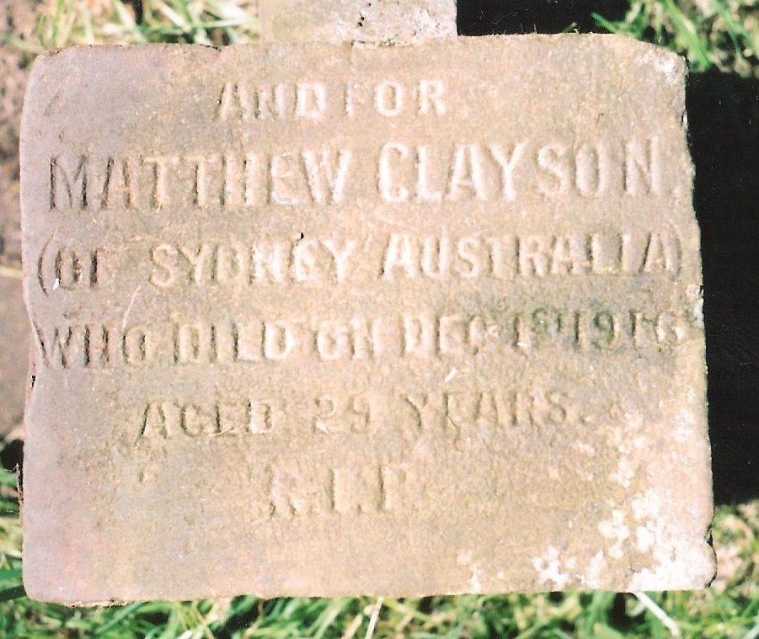
Left: Original Grave Marker
Right: Commonwealth War Graves Commission Headstone

Although Matthew Clayson did not die on the battlefield or of wounds, he gave his life as a volunteer in the service of Australia and the Empire. He certainly connected with St Werburgh’s in his short time in Chester. Therefore, we must remember and commemorate him and the young family that he left behind in Australia. After the Armistice Jennie and the two girls were offered the opportunity to return to her family in Manchester. However it is not clear if they did return, or if they remained in Australia with his family.

Sources: Griffiths, T. (2010). An industrial invasion. 1st ed. Terrey Hills, N. S. W.: Toptech Engineering.
The National Archives of Australia (NAA): MT1139/1, CLAYSON MATTHEW
The National Archives of the UK (TNA): RG, Census for England and Wales 1881
The National Archives of the UK (TNA): RG, Census for England and Wales 1891
The National Archives of the UK (TNA): RG, Census for England and Wales 1901
The National Archives of the UK (TNA): RG, Census for England and Wales 1911
General Register Office: Marriage Certificate, M Clayson & M A Ward 1884
The National Archives of the UK (TNA): BT, Passenger List: RMS Ophir May 1912
The National Archives of the UK (TNA): BT, Passenger List: RMS Suevic October 1913
NSW Registry of Births, Deaths & Marriages, Marriage Certificate M Clayson & J McCormick 1913
NSW Registry of Births, Deaths & Marriages, Death Certificate M A Clayson 1924

